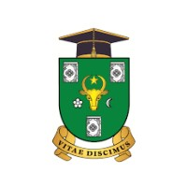
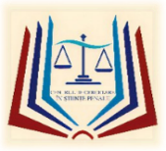
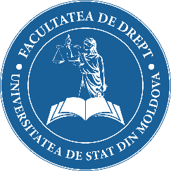
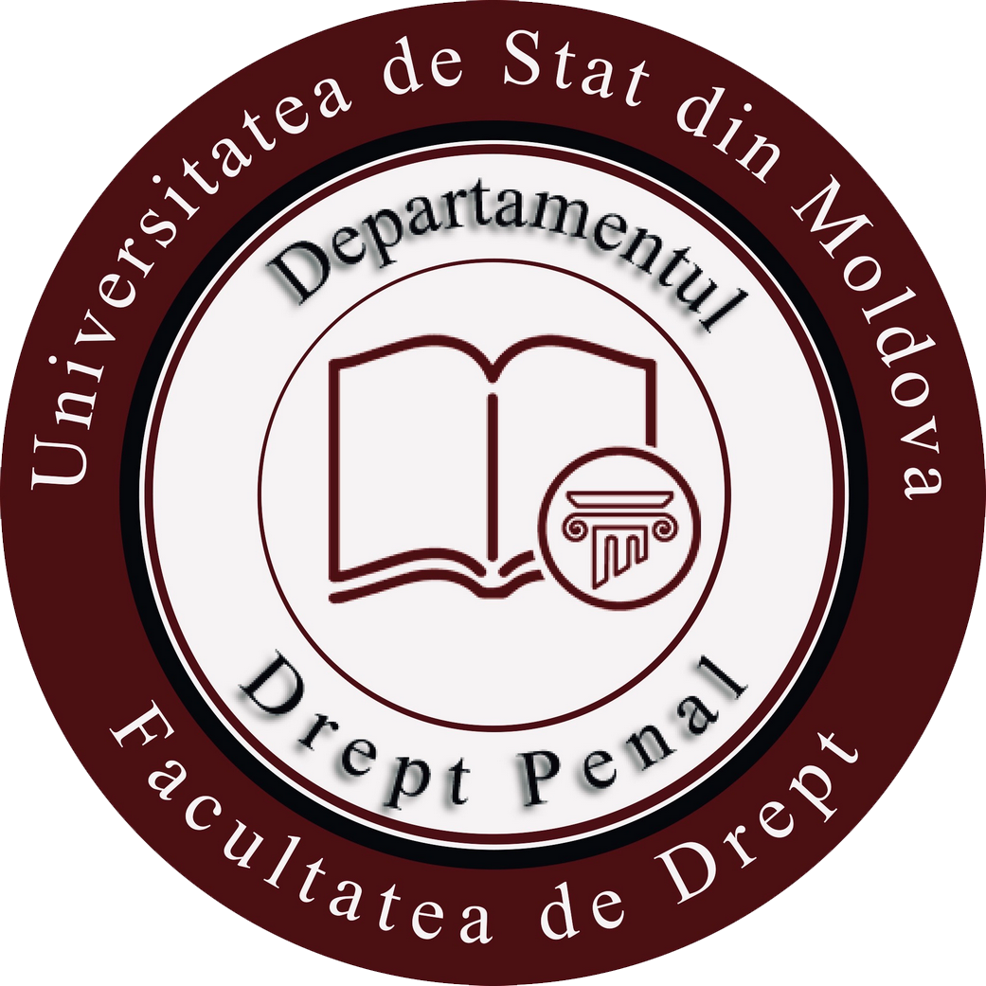

INTERNATIONAL SCIENTIFIC CONFERENCE

entitled "THE CHILD'S SUPERIOR INTEREST: SOCIO-CULTURAL, NORMATIVE AND JURISDICTIONAL APPROACH"

30th September - 1st October, 2022

INVITATION

Dear Participant,

The People's Advocate for the Rights of the Child in collaboration with the Department of Criminal Law of the Faculty of Law of the State University of Moldova organizes, in hybrid regime, between 30th September and 1st October, 2022, the International Scientific Conference, entitled "THE CHILD'S SUPERIOR INTEREST: SOCIO-CULTURAL, NORMATIVE AND JURISDICTIONAL APPROACH".

The aim of the conference is to provide a platform for scientific-practical discussions in the field of the protection of the rights of the child and, in particular, to ensure that the best interests of the child are taken into account when carrying out any procedural or decision-making act.
The exchange of opinions and knowledge, but also the search for answers to the most current questions that concern both doctrinaires and practitioners dedicated to the mission of protection of children's rights, will allow finding the best solutions to improve the legal framework in the field and identify good practice in the institutional and justice sectors.
The event is invited to participate representatives of public authorities and non-profit organizations, international organizations in the field of children's rights, representatives of academia, other interested persons (practitioners, doctoral students, master students), who directly or tangentially have professional interest in the field of reference. strengthening efforts to identify the most effective mechanisms to ensure the protection of the rights and interests of the child.
We are honored to invite you to participate in the conference proceedings, as appropriate, to delegate in the near future a representative of your institution who will communicate directly to us during the conference the vision of the public / or personal institution regarding the topic addressed, but not later than - 15th August, 2022. The conference agenda will be sent after you send us the subject of the communication that will

be included in the working panel of the event, but not later than 20th September, 2022.
The works of the conference will take place in hybrid format - online and inside the Faculty of Law (USM), block no. 2, hall no. 119 from str. K. Kogâlniceanu, no.67, 30th September, 2022 (09.00 - 17.00), Panel I - International and national standards in the field of protection of children's rights and interests; Panel II - Jurisprudential controversies in ensuring respect for the best interests of the child; 1st October, 2022 (09.00 - 14.00), Panel III - The role of guardianship authorities in ensuring respect for the best interests of the child.

Working languages: Romanian, English and Russian.

The works presented at the conference will be published in a separate collection.

Terms of reference:

- 1st September, 2022: sending the completed participation form to the organizers. Fill in the conference participation form here.
- 20th September, 2022: sending the conference program to the participants and the access link to the event.
- 30th October, 2022: reception of the conference proceedings, prepared according to the drafting requirements on the e-mail address: conferinta.penal@gmail.com

We are sure that this event will be the meeting place for several professionals from the Republic of Moldova and other states, involved in the protection of children's rights and will help strengthen the collaboration between academia and exponents of practical fields.

This conference is included in the Register of scientific events planned for 2022, approved by ANACEC.

* Note: For any questions related to the conference do not hesitate to contact the organizers: ȘAVGA Alina, doctor of law, associate professor, tel. + 373 (69890909), e-mail: alina.shavga@gmail.com and CATAN Anastasia, Head of the Directorate for the Promotion of Human Rights and Communication, Office of the People's Advocate, tel. + 373 (68155966), e-mail: anastasia.catan@ombudsman.md

Sincerely,

The People's Advocate for the Rights of the Child, Maia BĂNĂRESCU

Dean of the Faculty of Law of the State University of Moldova,
Serghei BRÎNZA, doctor of law, university professor

